CSC 150 – Program Design Document

**John Akujobi** – **CSC 150 S01**

**Structure Chart**

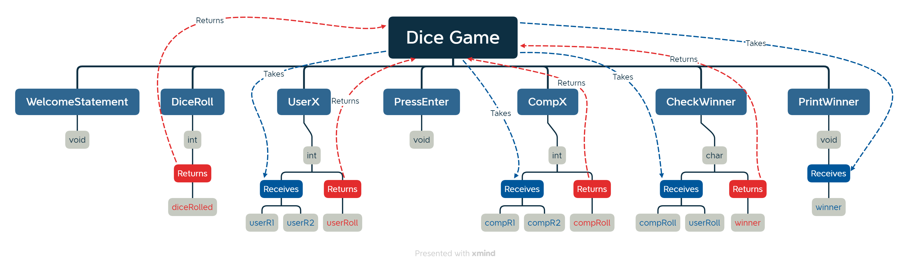

**Data Storage (defined in main)**

int userR1, userR2, userRoll, compR1, compR2, compRoll

char winner;

* int userR1
  + Stores the first dice roll for the user
* int userR2
  + Stores the second dice roll for the user
* int userRoll
  + Stores the sum of both dice rolls for the computer
* int compR1
  + Stores the first dice roll for the computer
* int compR2
  + Stores the second dice roll for the computer
* int compRoll
  + Stores the sum of both dice rolls for the computer
* char winner
  + Has a value of U for user and C for computer

**Function Design (for each function, give the function’s prototype and 1 or 2 lines describing how the function works.)**

* Void WelcomeStatement ();
  + Prints a welcome statement
  + And Tells the user how to play the game
* int DiceRoll ():
  + This function performs a dice roll by randomly selecting a number and limiting its range to 1-6
  + It returns the integer diceRolled
* Void PressEnter ();
  + This function pauses the game then continues after the user presses enter
* int UserX (int userR1, int userR2);
  + It sums the two dice rolled numbers userR1 and userR2
  + It prints this information to the user
  + It returns an integer userRoll
* int CompX (int compR1, int compR2);
  + It sums the two dice rolled numbers compR1 and compR2
  + It prints this information to the user
  + It returns an integer compRoll
* Char CheckWinner (int comp, int user);
  + This function receives the added dice rolls for both the computer and human
  + Then it checks the winner using the game rules and utilizes if and else statements
  + Assigns a value to **winner** either ‘U’ for User or ‘C’ for Computer
* void PrintWinner (char winner);
  + This function prints the winner of the game